Hello friend,

I have received the first feedback from my professor FOR THE ESSAY PAPER#2 AND NOT SHORT WRITING ASSINGMENT, and it is kind of bad news. He said that you needed to start again from the beginning because overall was not what the prompts asked you to do. He said that it was more wasting time and effort to revise them because every paragraph was more like a summary. The reasons are:

- The prompt asks you to analyze the significance of wars (WW2 is too broad); can you explain about Vietnam war in the revision? Your latest work was more like a summary of the class material. Each paragraph has to start with a strong thesis based on your argument in analyzing the significance of war and how it has shaped or impacted the particular Asian ethnic group experiences. There is also material about Vietnam on the PowerPoint slide on Canvas. Please read it.
- It has to be a specific group. For example, you only talk about Vietnamese.
- In each paragraph, your paper MUST consist of a clear/ strong thesis, supported by your own reasons, and backed up by evidence drawn MINIMUM ONE from the reading. For illustration, you give a strong thesis on your analysis of the significance of the Vietnam War toward the Vietnamese. For example, what happens before and after this war, and what are the impacts for them. Then each paragraph, you tell your reason. Also, in each paragraph, there must be a least one supporting evidence from the course reading. For most of your paragraph, there is no evidence at all. Please remember that the evidence is drawn from at least THREE different readings.
- Also, your paragraph was too short. Each paragraph has to have a strong main thesis, your reason, and the evidence from the book.
- Some of your formattings were wrong. Please see the WRITING GUIDELINES.
- You have to remember that this paper aims to persuade readers to think differently based on your own argument or perspective on the prompt. Not summarize. You have to emphasize what do you think about it more.
- THINK OF YOUR ESSAY WHICH YOU SEEK TO PERSUADE OR CONVINCE YOUR READER BASED ON YOUR PERSPECTIVE.

I know that some of them it was my mistake since I did not give you clear explanations. Therefore, after you finish with this, I will give you a good amount of bonus as my apologies to you. I need you to complete it asap because of the deadlines. Thank you! Please read the instructions carefully.

Please read:

THE PAPER IS GRADED ON HOW YOU UNDERSTAND THE MATERIAL’S CONCEPT TO CONVINCE YOUR PERSPECTIVE TO THE READERS BASED ON THE PROMPT. MY PROFESSOR WANTS TO KNOW WHETHER YOU HAVE COMPREHEND THE MATERIALS’S CONCEPTS OR NOT AND HE GRADED IT BASED ON THAT WAY. IT IS NOT GRADED BASED HOW WELL YOU DO THE SUMMARY; IT IS NOT WHAT THE PROMPT ASKS. THEREFORE, THERE IS NO CORRECT OR WRONG ANSWER. YOU HAVE TO BE MORE CRITICAL IN DOING THIS. THANK YOU!

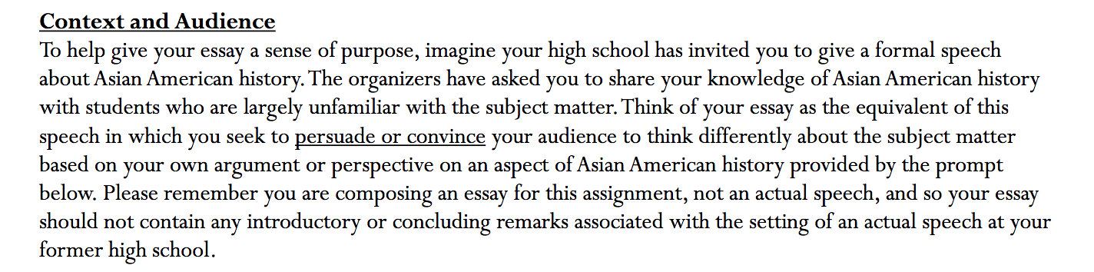
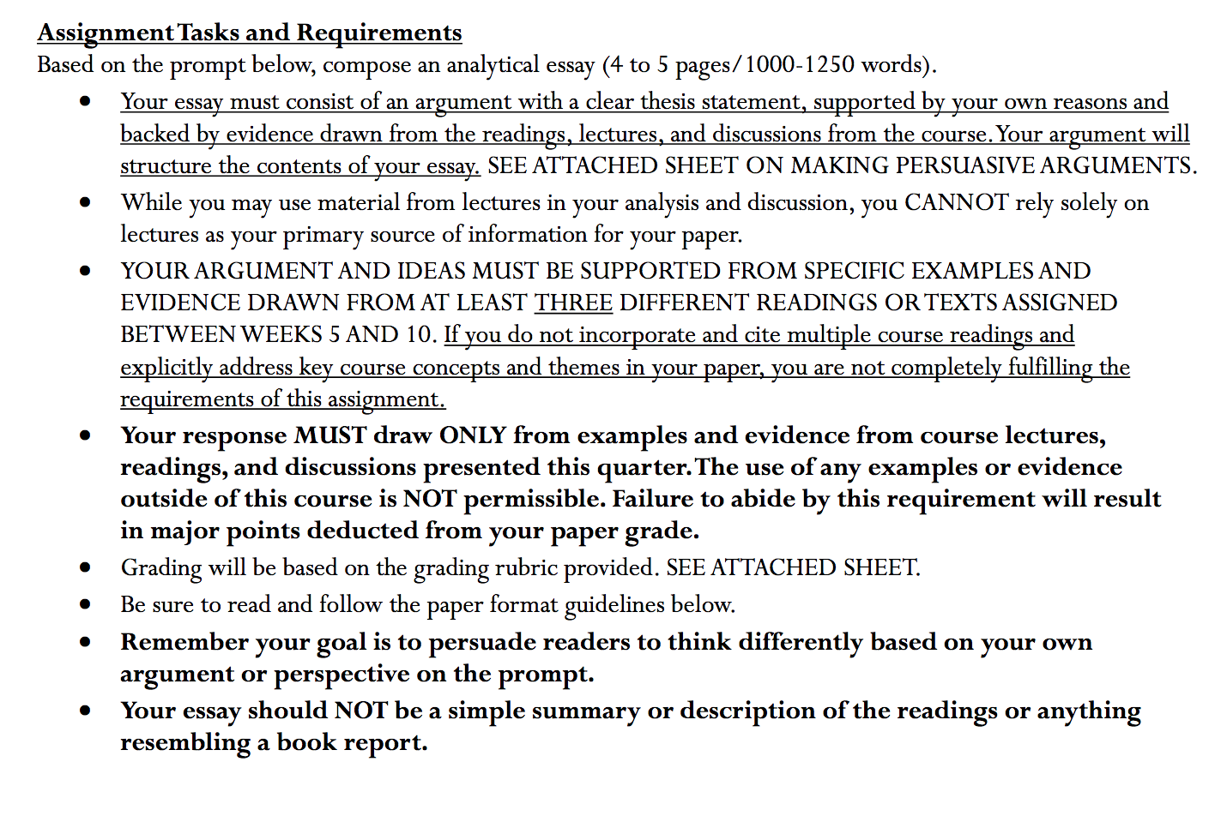
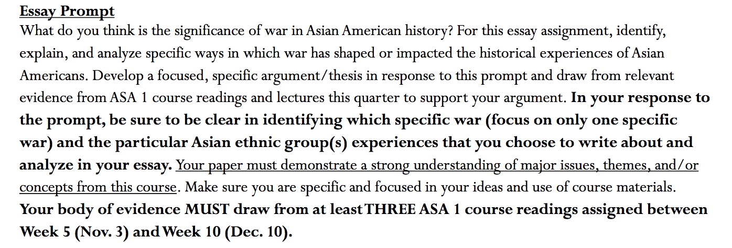

You are NOT SUMMARIZING. THIS IS AN ARGUMENTATIVE PAPER, WHERE YOU GIVE YOUR ARGUMENT AND CLEAR THESIS BASED ON THREE DIFFERENT COURSE READINGS. PLEASE READ!
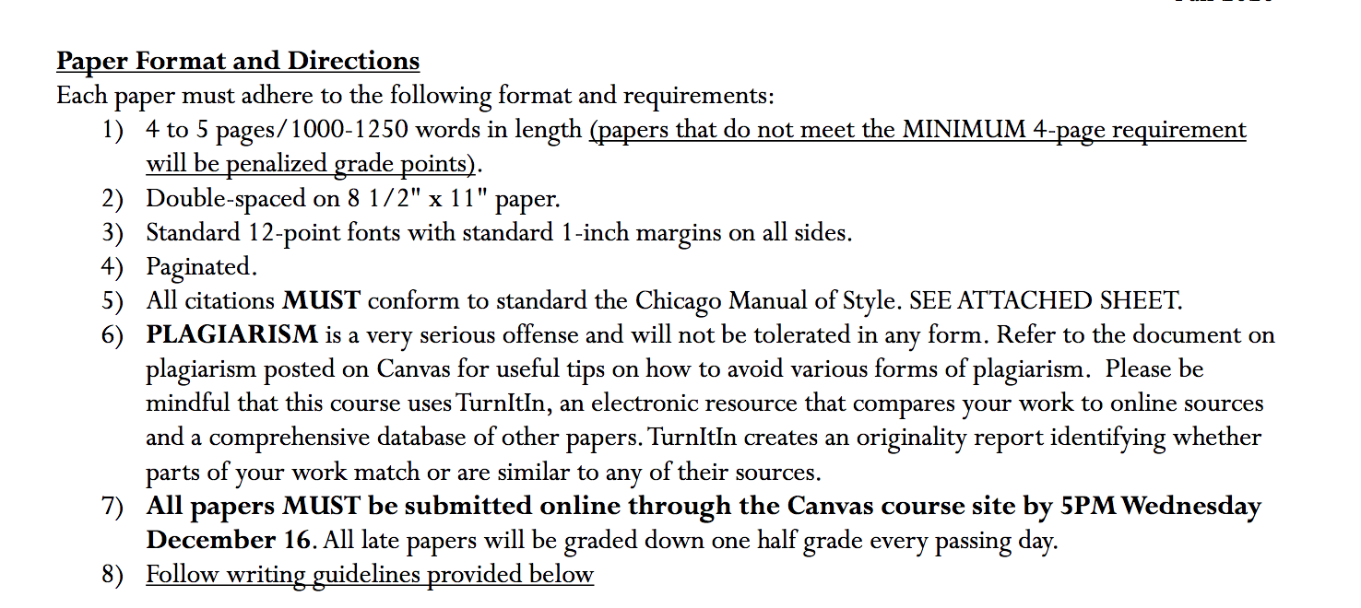

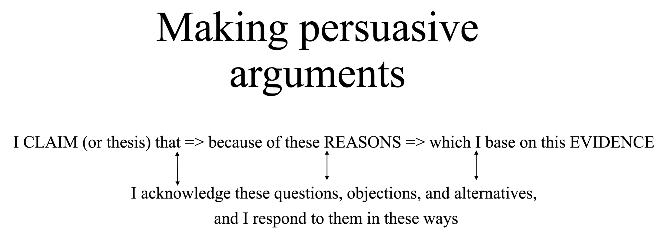

Your body of evidence must draw from at least THREE course reading assigned below!

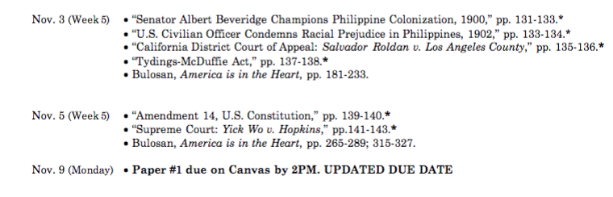

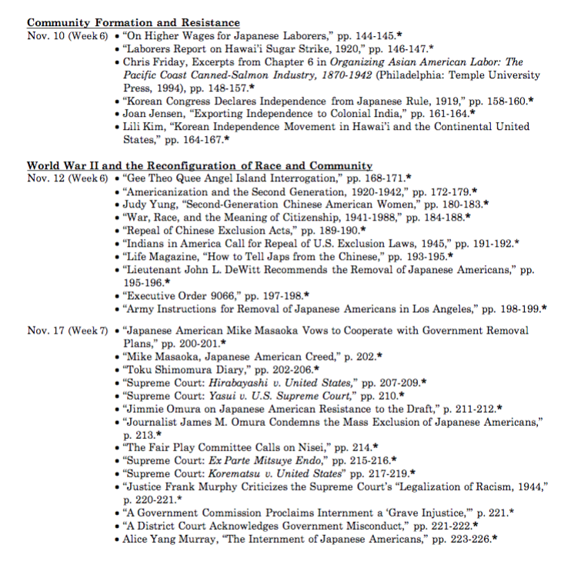

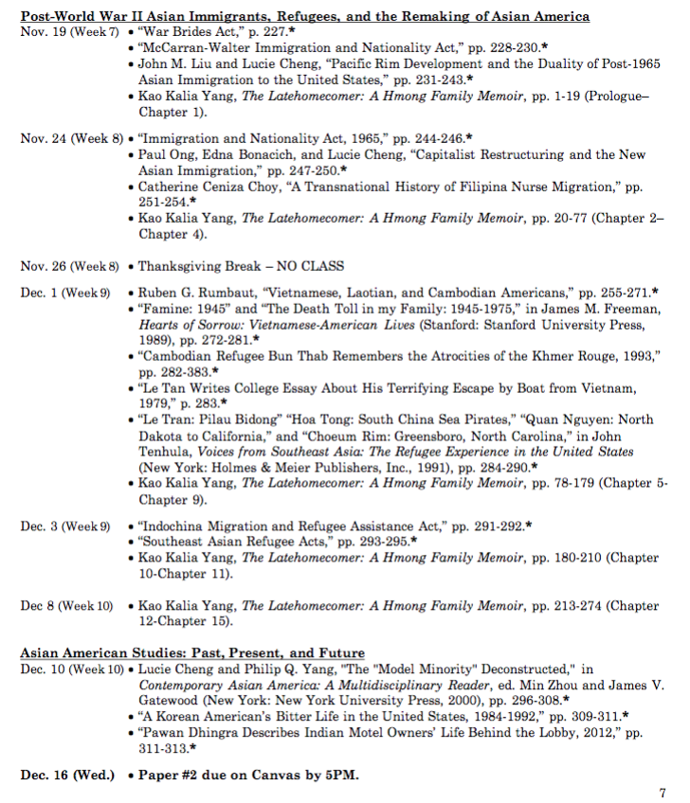

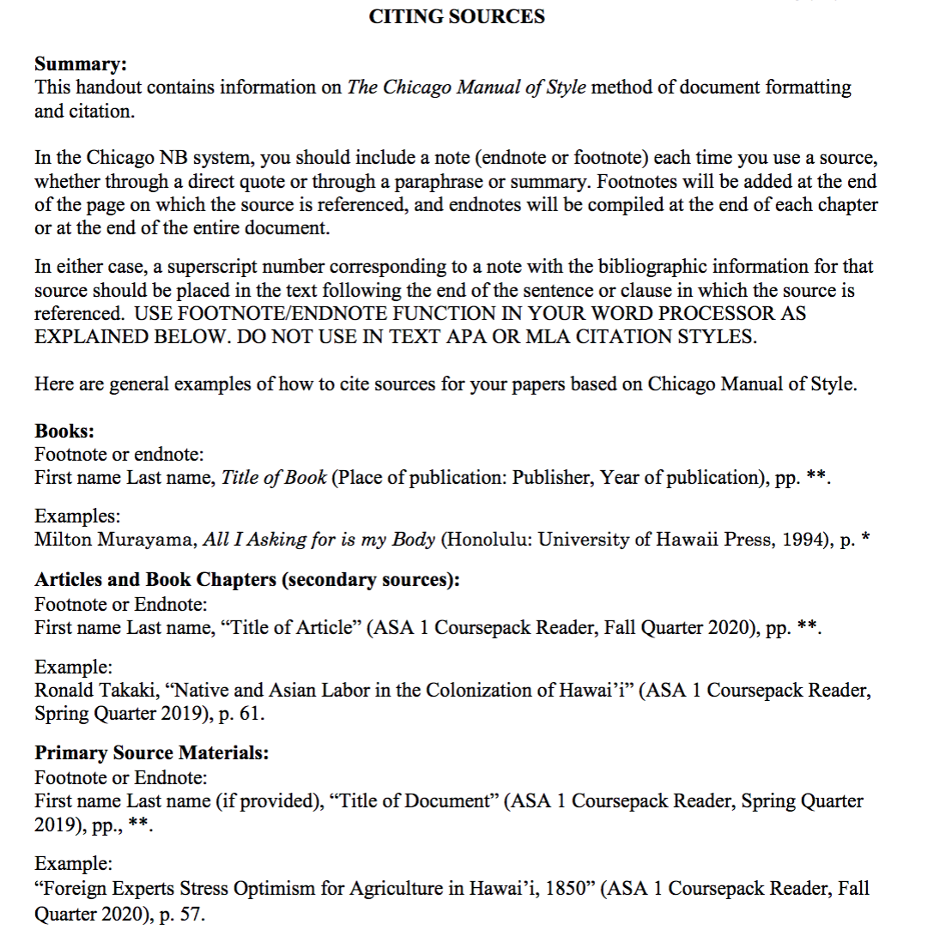

How to Access

Please see this link for the prompt and instruction!
https://canvas.ucdavis.edu/courses/511303
Then
UCD Login, which is the left one

Then
Username: sfelix
Password: GBumiPermai@F4/2

Then
See ASA 1 Paper #2 Prompt Essay Assignment.pdf in the bottom of the page

